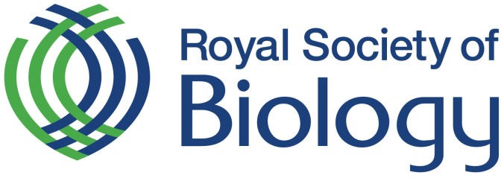

RISK ASSESSMENT

The Management of Health and Safety Regulation 1999 require under Regulation 3 that employers and self-employed persons must assess the risks posed to the health and safety of employees at work and all others affected by the undertaking.

The completion of a Risk Assessment clearly demonstrates that Exhibitors have understood their Health & Safety responsibilities to their staff, contractors and visitors. The undertaking of Risk Assessments is the first step to accident prevention; it is not intended to be unworkable or to intimidate. It should highlight any potential risks to staff, contractors or visitors and identify effective measures to either eliminate the risk or reduce it to the lowest possible level.

Royal Society of Biology will inform all volunteers and staff of safety precautions for the Royal Society of Biology’s (event or activity name) in advance of the event.

Royal Society of Biology

Date
DEFINITIONS:

SEVERITY

HIGH | 3 | Fatality or major injury causing long term disability
MEDIUM | 2 | Injury or illness causing short-term disability
LOW | 1 | Other injury or illness

LIKELIHOOD

HIGH | 3 | Certain or near certain
MEDIUM | 2 | Reasonably likely
LOW | 1 | Very seldom or never

SEVERITY X LIKELIHOOD = RISK RATING

Risk Matrix

Likelihood

Severity |  | H | M | L
 | H | 9 | 6 | 3
 | M | 6 | 4 | 2
 | L | 3 | 2 | 1

Risk Rating

6 - 9 = High risk – action required to reduce risk

3 - 4 = Medium risk – seek to further reduce risk

1 - 2= Low risk – no action but continue to monitor

RISK ASSESSMENT
Event: |  | Date: | Assessors Name:
Company Name: Royal Society of Biology |  | Summary of activities:
Risk | To whom: | Minimise risk by: |  | Risk Rating:  Severity x Likelihood = Risk rating
 |  |  |  | S | L | R

ADDITIONAL INFORMATION

