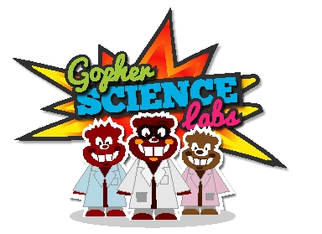

CONGRATULATIONS!

is now a Level 2 Gopher and has demonstrated and explained a range of scientific phenomena to others.

Certified by

Date:

Gopher Science Labs was developed by the Royal Society of Biology and the Biochemical Society.

